**FocussedModePlus User Guide**

Introduction

Desktop clutter can be a source of stress and anxiety for people with autism, who may have difficulties with sensory processing, executive functioning, and emotional regulation. Clutter can create visual, auditory, and tactile distractions that interfere with their focus, concentration, and productivity. Clutter can also trigger negative emotions such as frustration, shame, resentment etc. and can easily overwhelm them which can affect their self-esteem and mental health.

Desktop clutter can also pose challenges for people with autism in terms of organizing, prioritizing, and completing tasks. People with autism may have trouble finding what they need, remembering what they have to do, and following a sequence of steps to accomplish their goals. Clutter can also make it harder for them to maintain a routine, stick to a schedule, and cope with changes or transitions. Clutter can also reduce their motivation and satisfaction with their work or studies.

Desktop clutter can be reduced or prevented by applying some strategies that suit the needs and preferences of people with autism. Some possible strategies are: using labels, containers, folders, and drawers to sort and store items; creating designated zones for different activities or purposes; setting a timer and a limit for how much clutter to clear at a time; asking for help from a friend, family member, or professional organizer; and rewarding oneself for decluttering efforts.

Desktop Clutter

The issue of Desktop Clutter needs to be looked at a bit more closely. Without beating around the bush, I’d like to put forth a few Scenarios – and then take it from there…

* There are many Icons / files / folders on the Desktop. This can be confusing / disorienting (even for Normal people)
* There is an Open Application (say Photoshop / Premier Pro etc.). In many such softwares, there can be many different components – such as Toolbars, Menus, Menu Items, Tool Buttons, Dialogs, Pop-ups, Frames, MDI Windows, Notifications….. the list just goes on and on. Again, all these components taken together, can lead to Increased Stress levels, confusion and loss of Productivity
* In some Apps – there may be very Bright / Flashy Color themes or Special Effects that are used. Certain Color combinations / frequent changes in Colors / Patterns can cause Visual Stress in Persons with Autism
* Even while reading or typing a Document in Word – there are many Sentences / Words that might be visible at one shot. While for a Normal person – there may be no problems in reading or typing a Word Document… For people with Autism – their brains are wired differently – and so, they may tend to take in all the available information at once. As a result, it becomes very difficult for them to process all this information simultaneously. This is often referred to as Sensory Overload. Sensory Overload is one of the main reasons why persons with Autism find it difficult to accomplish seemingly trivial tasks – despite having Above Average Intelligence.

Strategies to deal with Desktop Clutter

Here are some possible strategies to deal with desktop clutter for people with autism:

* Create storage folders with specific and descriptive names that match the user’s interests and needs. [For example, instead of having a folder named “Documents”, have folders named “School Projects”, “Personal Writing”, “Bills and Receipts”, etc.](https://support.microsoft.com/en-gb/topic/accessibility-tools-for-neurodiversity-6dbd8065-b543-4cf8-bdfb-7c84d9e8f74a)[1](https://support.microsoft.com/en-gb/topic/accessibility-tools-for-neurodiversity-6dbd8065-b543-4cf8-bdfb-7c84d9e8f74a)
* Use color coding to organize the folders and files by category, priority, or mood. [For example, use red for urgent tasks, green for completed tasks, blue for relaxing activities, etc.](https://support.microsoft.com/en-gb/topic/accessibility-tools-for-neurodiversity-6dbd8065-b543-4cf8-bdfb-7c84d9e8f74a)[1](https://support.microsoft.com/en-gb/topic/accessibility-tools-for-neurodiversity-6dbd8065-b543-4cf8-bdfb-7c84d9e8f74a)
* Use icons or images that are meaningful and appealing to the user to label the folders and files. [For example, use a picture of a book for a folder containing ebooks, or a picture of a guitar for a folder containing music files.](https://support.microsoft.com/en-gb/topic/accessibility-tools-for-neurodiversity-6dbd8065-b543-4cf8-bdfb-7c84d9e8f74a)[1](https://support.microsoft.com/en-gb/topic/accessibility-tools-for-neurodiversity-6dbd8065-b543-4cf8-bdfb-7c84d9e8f74a)
* Delete or archive any files or folders that are no longer needed or used. [This will free up space and reduce visual clutter on the desktop.](https://support.microsoft.com/en-gb/topic/accessibility-tools-for-neurodiversity-6dbd8065-b543-4cf8-bdfb-7c84d9e8f74a)[1](https://support.microsoft.com/en-gb/topic/accessibility-tools-for-neurodiversity-6dbd8065-b543-4cf8-bdfb-7c84d9e8f74a)
* Arrange the folders and files on the desktop in a way that makes sense to the user and follows their preferred pattern or logic. [For example, use a grid, a circle, a spiral, or a random layout.](https://support.microsoft.com/en-gb/topic/accessibility-tools-for-neurodiversity-6dbd8065-b543-4cf8-bdfb-7c84d9e8f74a)[1](https://support.microsoft.com/en-gb/topic/accessibility-tools-for-neurodiversity-6dbd8065-b543-4cf8-bdfb-7c84d9e8f74a)
* Use a desktop wallpaper or background that is calming and soothing to the user, and does not distract or overwhelm them. [For example, use a solid color, a gradient, a nature scene, or a personal photo.](https://support.microsoft.com/en-gb/topic/accessibility-tools-for-neurodiversity-6dbd8065-b543-4cf8-bdfb-7c84d9e8f74a)[1](https://support.microsoft.com/en-gb/topic/accessibility-tools-for-neurodiversity-6dbd8065-b543-4cf8-bdfb-7c84d9e8f74a)
* Adjust the brightness, contrast, and size of the desktop screen to suit the user’s visual preferences and needs. [For example, use a lower brightness and contrast for a user who is sensitive to light, or a higher brightness and contrast for a user who needs more stimulation.](https://support.microsoft.com/en-gb/topic/accessibility-tools-for-neurodiversity-6dbd8065-b543-4cf8-bdfb-7c84d9e8f74a)[2](https://www.understood.org/en/articles/adhd-tip-declutter-your-cpu-desktop-screen)
* Use accessibility tools and features that are available on Windows and Microsoft 365 to help the user with neurodiversity-related challenges. [For example, use the Immersive Reader to read text aloud, use the Dictate feature to type with voice, use the Focus Assist to block notifications, use the Magnifier to zoom in or out, etc.](https://support.microsoft.com/en-gb/topic/accessibility-tools-for-neurodiversity-6dbd8065-b543-4cf8-bdfb-7c84d9e8f74a)[3](https://planitperfectlife.com/2021/02/organizing-on-the-spectrum/)
* Set a regular schedule or reminder to clean and organize the desktop screen at least once a week or month. [This will help the user maintain a habit of decluttering and avoid accumulation of clutter over time.1](https://support.microsoft.com/en-gb/topic/accessibility-tools-for-neurodiversity-6dbd8065-b543-4cf8-bdfb-7c84d9e8f74a)
* Seek help or guidance from a trusted person, such as a family member, a friend, a teacher, or a professional organizer, if the user feels overwhelmed or stuck with decluttering their desktop screen. [They can provide support, feedback, and suggestions to make the process easier and more enjoyable.](https://support.microsoft.com/en-gb/topic/accessibility-tools-for-neurodiversity-6dbd8065-b543-4cf8-bdfb-7c84d9e8f74a)[1](https://support.microsoft.com/en-gb/topic/accessibility-tools-for-neurodiversity-6dbd8065-b543-4cf8-bdfb-7c84d9e8f74a)[3](https://planitperfectlife.com/2021/02/organizing-on-the-spectrum/)

I hope these bullet points are helpful to you! 😊

**FocussedModePlus and its Approach**

FocussedModePlus takes a different Approach to solving the problem of Desktop Clutter. It doesn’t try to get to the root of the problem (eliminating Desktop Clutter). Rather, it tries to create a layer of Focus Over it. FocussedModePlus creates an Opaque (or Dark) layer over the Desktop. Only a small part of the Desktop is visible to the user. This Transparent Area moves wherever the mouse pointer is moved. For more precise movements – Arrow keys are also supported.

When FocussedModePlus is launched – the entire Screen goes Blank (or Dark). Only a small rectangular area near the mouse pointer remains Transparent. This enables the user to focus only on that area. There’re no other distractions – as almost the entire Screen is Dark. Further, the Transparent Area moves wherever the mouse pointer is moved. So the user can choose to focus on any particular area of the Desktop (as per their need) – from time to time. The FocussedModePlus utility is very much lightweight and responsive – so there’s no delay in movement of the Transparent area.

FocussedModePlus provides a basic set of features – designed to help users work more effectively with the App. Every feature has a Simple Key Binding Associated with it. These Keybindings work as long as FocussedModePlus is in focus. If Keybindings are not working – it probably means that FocussedModePlus has lost focus. In such situations – either use ‘Alt + Tab’ key combo or Click on the FocussedModePlus App Icon on the Taskbar – to bring it back into focus. Then, the keybindings will work again.

For a full list of Features and their Associated Keybindings – refer to the next Section……

Keybindings

For a full list of Keybindings – refer to the below table…

|  |  |  |
| --- | --- | --- |
| Key | -> | What it Does |
| M | -> | Minimizes FocussedModePlus to the Taskbar |
| Q | -> | Quits the FocussedModePlus App |
| - | -> | decrease width of Transparent Area |
| = | -> | increase width of Transparent Area |
| , | -> | decrease height of Transparent Area |
| . | -> | increase height of Transparent Area |
| _ | -> | decrease Horizontal Speed of Transparent Area |
| + | -> | increase Horizontal Speed of Transparent Area |
| < | -> | decrease Vertical Speed of Transparent Area |
| > | -> | increase Vertical Speed of Transparent Area |
|  |  |  |

More features may be added in future – as a result keybindings may change *

Use Cases for FocussedModePlus

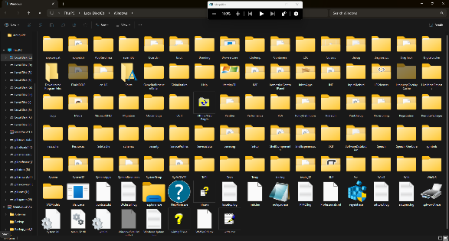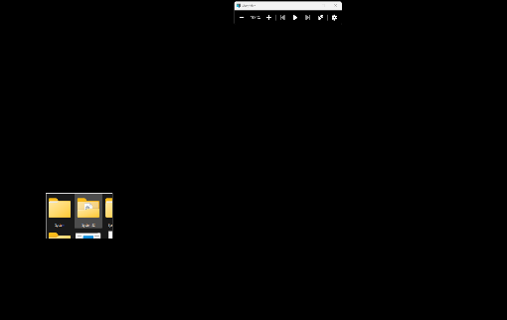

1. Navigating through many icons / files / folders on the Desktop
   * Navigate to the folder / Desktop with many icons / files
   * Launch FocussedModePlus
   * Adjust the width / height of the Transparent area as per your requirements – by pressing the appropriate keys
   * Move the mouse over each icon / file / folder as needed – until you find the item where you want to navigate to
   * Click on the desired item
   * Press ‘m’ (while FocussedModePlus is in focus) – to minimize it if / when needed

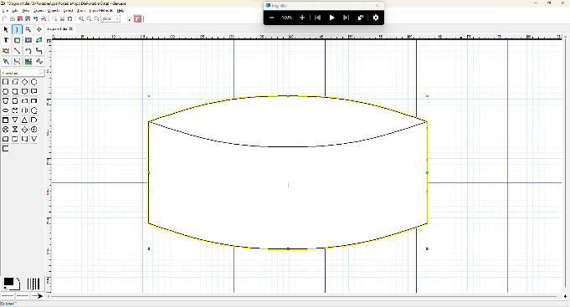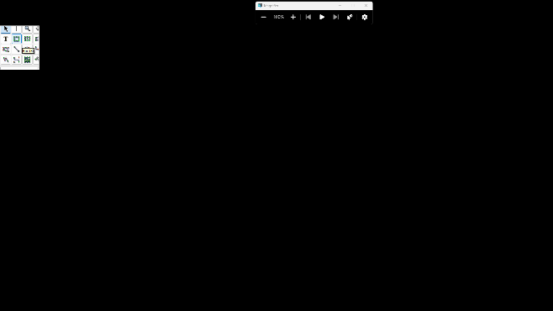

1. Working on an Application with multiple Toolbars / Menus etc.
   * Open the Application you need to work on (eg. Photoshop)
   * Launch FocussedModePlus
   * Adjust the width / height of the Transparent area as per your requirements – by pressing the appropriate keys
   * Move the mouse over each menu / toolbar button / menu item etc. as needed – until you find the item where you want to navigate to / click on
   * Click on the desired item
   * Press ‘m’ (while FocussedModePlus is in focus) – to minimize it if / when needed

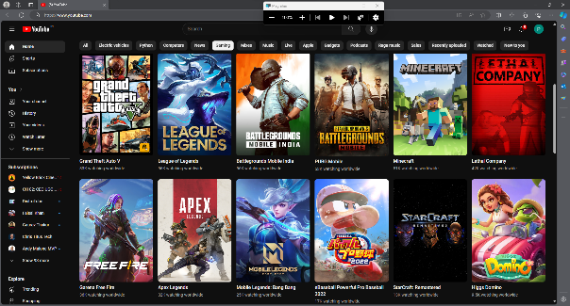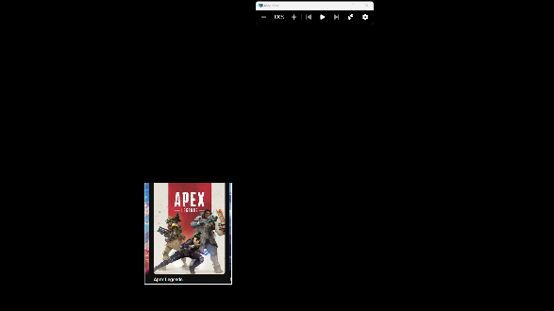

1. Working on Apps with Flashy Color themes
   * Open the Application you need to work on (the App with Flashy Color themes)
   * Launch FocussedModePlus
   * Adjust the width / height of the Transparent area as per your requirements – by pressing the appropriate keys (keep the Size of the Transparent area to a bare minimum as per requirements)
   * Move the mouse over each menu / toolbar button / menu item etc. as needed – until you find the item where you want to navigate to / click on
   * Click on the desired item
   * Move the Transparent area to a place where Colors are less intense / flashy
   * Once the task is done – close the Flashy App
   * Press ‘m’ (while FocussedModePlus is in focus) – to minimize it if / when needed

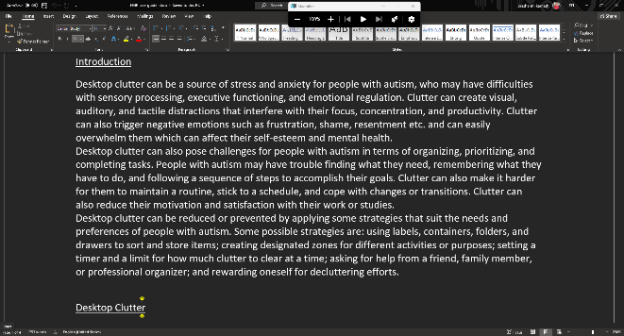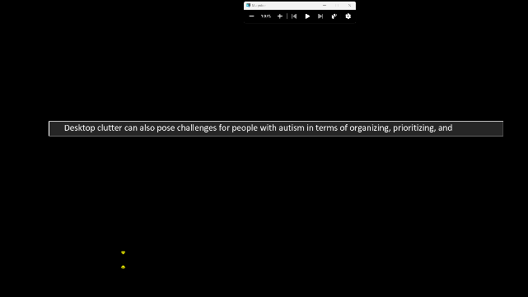

1. Reading / Typing a Document in Word
   * Open the Application you need to work on (eg. Word)
   * Launch FocussedModePlus
   * Adjust the width / height of the Transparent area as per your requirements – by pressing the appropriate keys
   * FocussedModePlus can help you read word by word OR line by line
   * Move the mouse over each word / line that you wish to read
   * While typing, the App in focus is Word. Here, as you type – the Text cursor may go outside the Transparent area. If / when this happens – move the mouse pointer to bring the Text cursor back within the Transparent area. This is a current limitation – that could be fixed in future versions
   * Press ‘m’ (while FocussedModePlus is in focus) – to minimize it if / when needed